**Lab 6:**

**Diodes**

Name: Wan-Yu Liao

ECEN 325 Section 514

TA: Mandela

Lab Date: October 11, 2019

Lab Report Due Date: October 14, 2019

**Calculation**

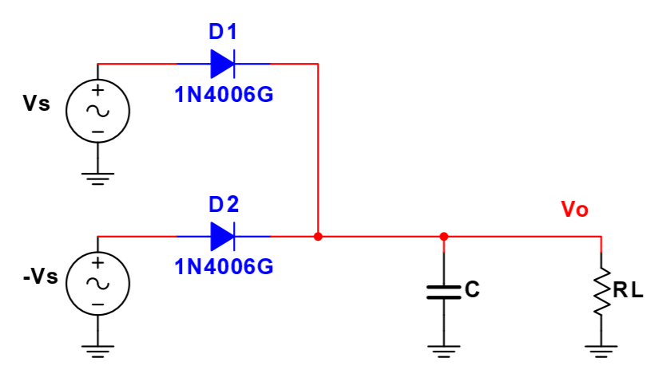



**Simulations**

**(1)**

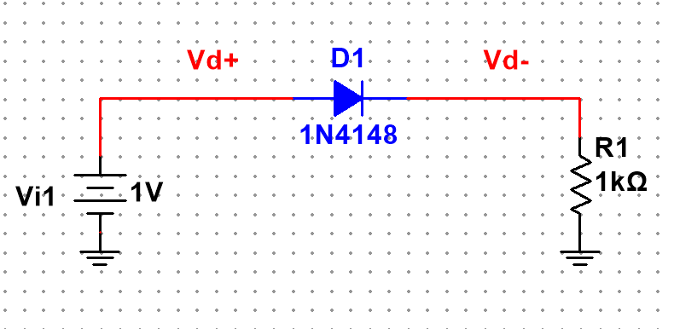

Figure 1: Schematic for Fig. 2(a) ▲

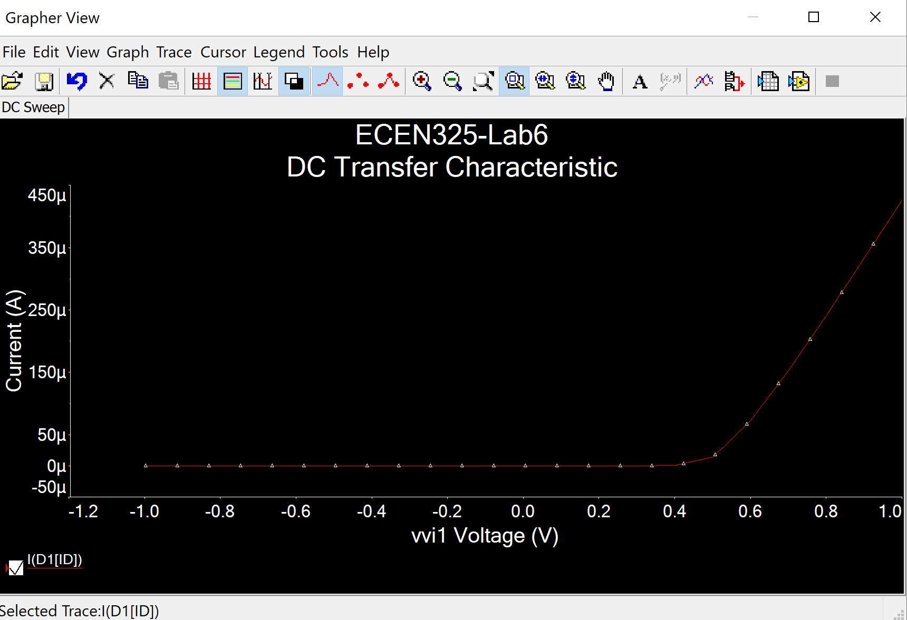

Figure 2: DC sweep simulation plot for Fig. 2(a) where Vstep = 0.1 from -1 V to 1 V▲

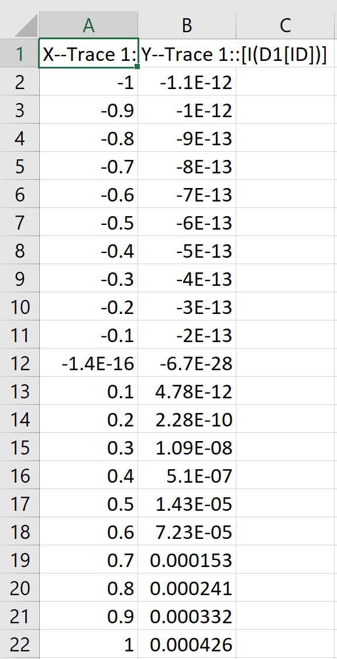

Figure 3: Simulation data for Fig. 2(a) ▲

Figure 4: Excel data plot for Fig. 2(a) where Vstep = 0.1 from -1 V to 1 V ▲

(2)

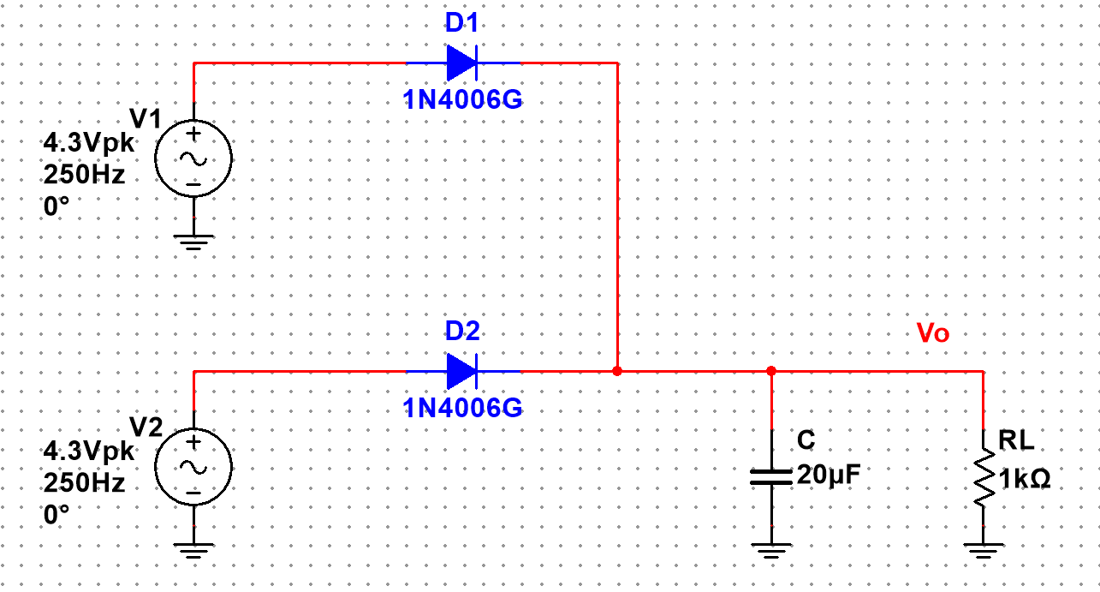

Figure 5: Schematic for Fig. 5 with calculated values▲

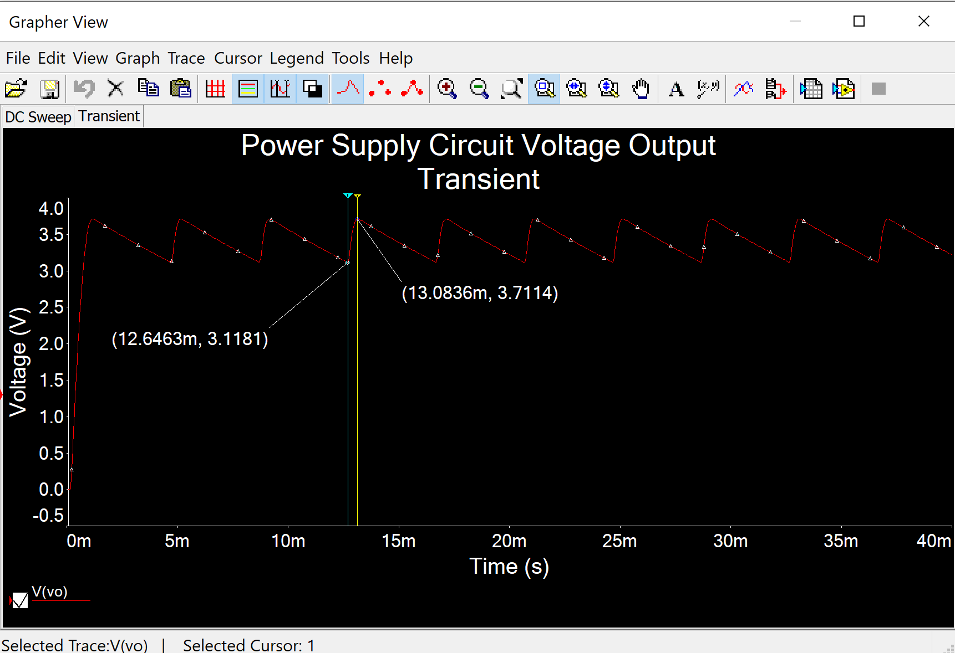

Figure 6: Power supply circuit transient simulation for voltage output▲

Voltage high peak = 3.7114 V, Voltage low peak = 3.1181 V

Max ripple = (3.7114-3.1181)/[(3.7114+3.1181)/2]*100% = 17%

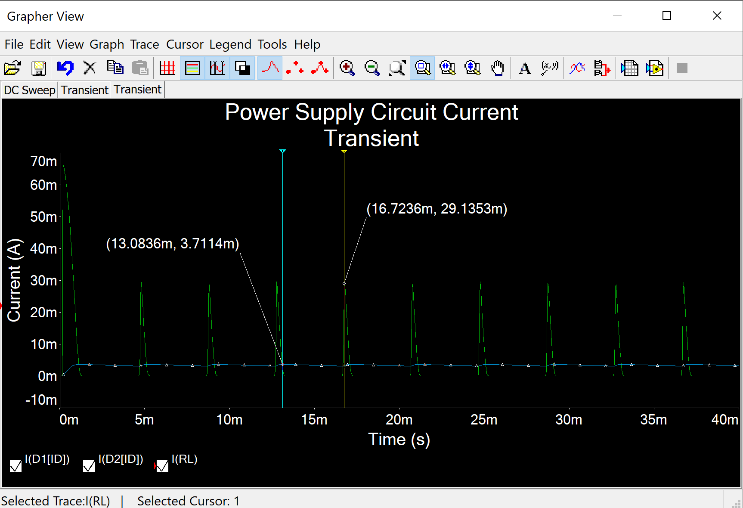

Figure 7: Power supply circuit transient simulation for currents ▲

Peak current on diodes = 29.1353 mA for both D1 and D2

Peak current on load resistor = 3.7114 mA

**Measurements**

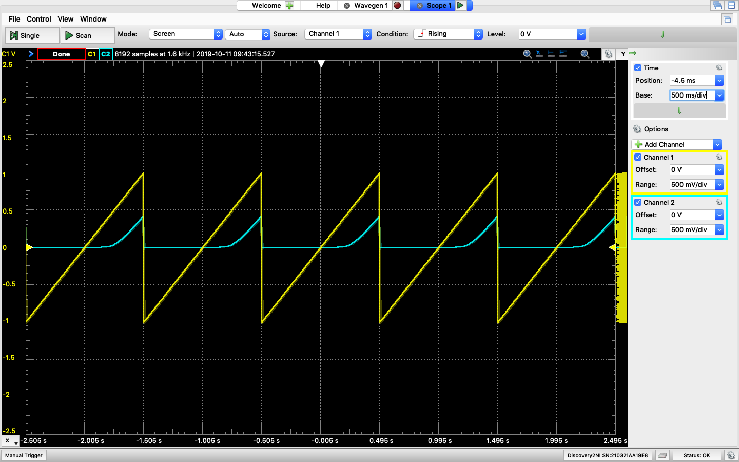

Figure 8: Waveform output for Fig. 2(a) where Vi = RampUp waveform▲

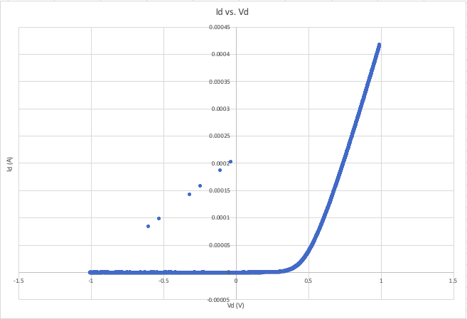

Figure 9: Excel data plot showing current of diode vs. voltage of diode for Fig. 2(a) using data from Figure 8 ▲

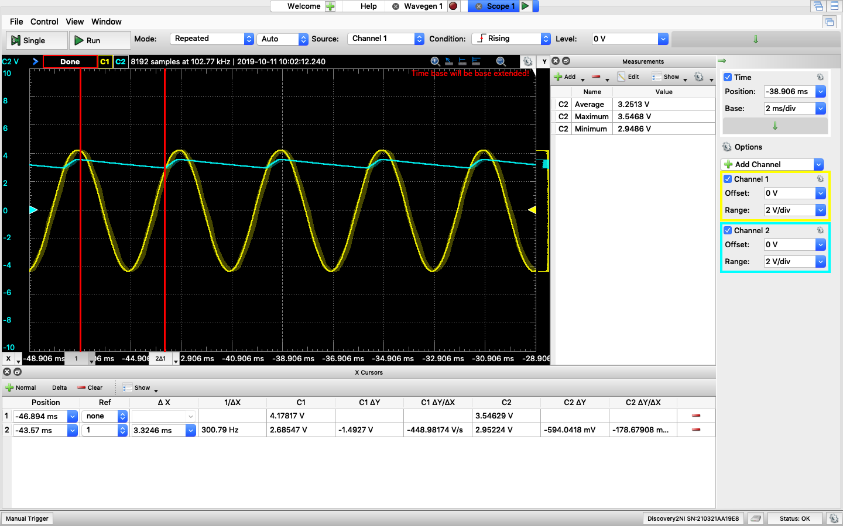

Figure 10: Power supply circuit waveform ▲

Voltage high peak = 3.5468 V, Voltage low peak = 2.9486 V, Voltage Average = 3.2513 V

Max ripple = (3.5468-2.9486)/[3.2513]*100% = 18%

**Table**

|  |  |  |  |
| --- | --- | --- | --- |
|  | Calculation | Simulation | Measurement |
| Peak Output Voltage (High) | 3.3 V | 3.7114 V | 3.5468 V |
| Peak Output Voltage (Low) |  | 3.1181 V | 2.9486 V |
| Max Ripple | 10% | 17% | 18% |

**Comment**

Based on the table above, the values are very close for calculation, simulation, and measurement parts except for max ripple. Max ripple for simulation and measurement are close but is different from calculation.

For excel data plot of Id vs. Vd, Id started going up at around Vd = 0.4 V for both simulation and measurement. This means that for 1N4148 diode, minimal voltage to turn it on is about 0.4 V which is the forward voltage for 1N4148 diode.